### Supplementary data

**Figure S1** An example of total ion chromatogram of samples from the three groups, QC and the solvent runs; a) sample form the healthy group; b) sample from the ulcerative colitis patient; c) Sample from Crhon’s disease patient; d) mix from all the samples as quality control- QC; e) sample from the solvents as negative control.

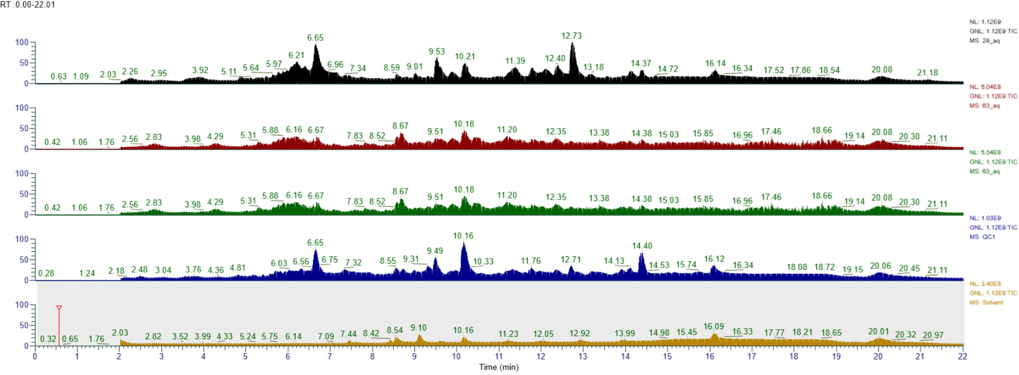

**a**

**b**

**c**

**d**

**e**

|  |  |  |  |  |  |
| --- | --- | --- | --- | --- | --- |
| **Category** | **Characteristic** | **HC (n=49)** | **UC (n=31)** | **CD (n=39)** | **P-value** |
| **Demographics** |  |  |  |  |  |
|  | Age (years; mean ± SD) | 34.2 ± 9.8 | 36.5 ± 11.2 | 36.8 ± 10.5 | 0.42 |
|  | Age range | 19-58 | 22-70 | 20-65 | - |
|  | Male n (%) | 25 (51.0) | 16 (51.6) | 13 (33.3) | 0.18 |
|  | Female n (%) | 24 (49.0) | 15 (48.4) | 26 (66.7) | - |
| **Clinical Characteristics** |  |  |  |  |  |
|  | Disease Duration (years; mean ± SD) | N/A | 8.2 ± 6.4 | 9.1 ± 7.2 | 0.56 |
|  | Current Smoker n (%) | 7 (14.3) | 3 (9.7) | 5 (12.8) | 0.84 |
|  | Former Smoker n (%) | 5 (10.2) | 4 (12.9) | 6 (15.4) | - |
|  | Never Smoker n (%) | 37 (75.5) | 24 (77.4) | 28 (71.8) | - |
| **Disease Activity** |  |  |  |  |  |
|  | Mayo Score (mean ± SD) | N/A | 6.6 ± 2.8 | N/A | - |
|  | Calprotectin μg/g (mean ± SD) | N/A | 285 ± 156 | 312 ± 178 | 0.48 |
| **Dietary Habits** |  |  |  |  |  |
|  | Special Diet n (%) | 12 (24.5) | 15 (48.4) | 22 (56.4) | <0.01 |
|  | Gluten-free n (%) | 3 (6.1) | 5 (16.1) | 8 (20.5) | 0.03 |
|  | Lactose-free n (%) | 4 (8.2) | 6 (19.4) | 9 (23.1) | 0.02 |
|  | Other dietary restrictions n (%) | 5 (10.2) | 4 (12.9) | 5 (12.8) | 0.89 |
| **Supplements** |  |  |  |  |  |
|  | Any Dietary Supplements n (%) | 15 (30.6) | 18 (58.1) | 25 (64.1) | <0.01 |
|  | Vitamin D n (%) | 8 (16.3) | 12 (38.7) | 15 (38.5) | 0.02 |
|  | Iron n (%) | 3 (6.1) | 8 (25.8) | 12 (30.8) | <0.01 |
|  | Multiple vitamins n (%) | 7 (14.3) | 9 (29.0) | 11 (28.2) | 0.15 |
| **Medications** |  |  |  |  |  |
|  | Any IBD medication n (%) | N/A | 28 (90.3) | 35 (89.7) | 0.93 |
|  | Biologics n (%) | N/A | 12 (38.7) | 18 (46.2) | 0.54 |
|  | Immunomodulators n (%) | N/A | 15 (48.4) | 21 (53.8) | 0.65 |
|  | 5-ASA n (%) | N/A | 22 (71.0) | 15 (38.5) | <0.01 |

**Table S2** Demographic and Clinical Characteristics. Data presented as mean ± standard deviation. N/A: Not applicable. P-values were calculated using the Chi-square test for categorical variables and Student's t-test or ANOVA for continuous variables as appropriate.

**Figure S2** MS2 spectra for the chromatogram peaks shown in figure 9; a) QC Rt 5.57min; b) Stander after five days at Rt 5.64min; c) Standard after five days at Rt 7.79 min; d) standartd at Rt 7.66 without expsure to oxigen.



**c**

**b**

**a**

**d**

**Figure S3** Chromatogram of the QC and the standard; a) The QC chromatogram - the peak shown is for m/z 593.3334;  
b) The standard after 5 days is to be exposed to light and oxygen; c) The standard is directly from the manufacturer’s vail without exposure to oxygen and light.



**c**

**b**

**a**

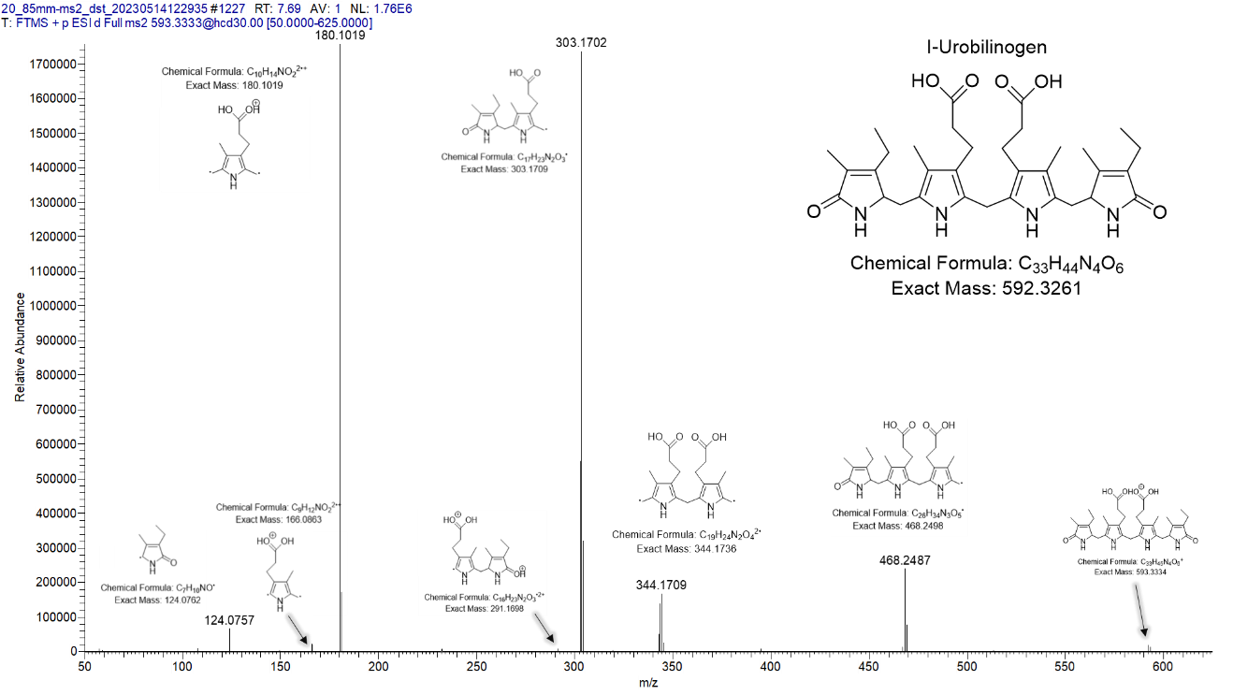

**Figure S4** Identification of all fragment peaks accompanying the parent compound with m/z 593.3332.   
The detection was done manually and strengthened by SIRIUS prediction.